Student’s Name: Cyron Hercules

Lecturer’s Name: S.Mohammed

Subject’s Name: Web Design

Date:

Cryon’s Clothing Store Launch Report

Good day, thanks again for the further opportunities you gave me to do these tasks. I have made a few changes to the website’s layout and added a few functionalities, such as a contact form and an animation on the home page to give it a more feel. A new wireframe for this website is shown below for both mobile and desktop views. At the top of the page, I added a Call to Action so that the user knows this is exactly where they want to go shopping for their items. There are 2 things, however, that I had not gotten a chance to complete and that are the Sorting Options for the shop and the login form. **Server-side connectivity to a database can be established in the future** to assist in sorting out these items and allowing a user to login into their account so that they can then make purchases.  
  
 I hope that you are pleased with my report and I look forward to more upcoming assignments.

I have created a wireframe for the website as shown below so you can have a quick idea of how I planned it out before I started the development process(coding). For reference, CTA means Call to Action

**DESKTOP VIEW**

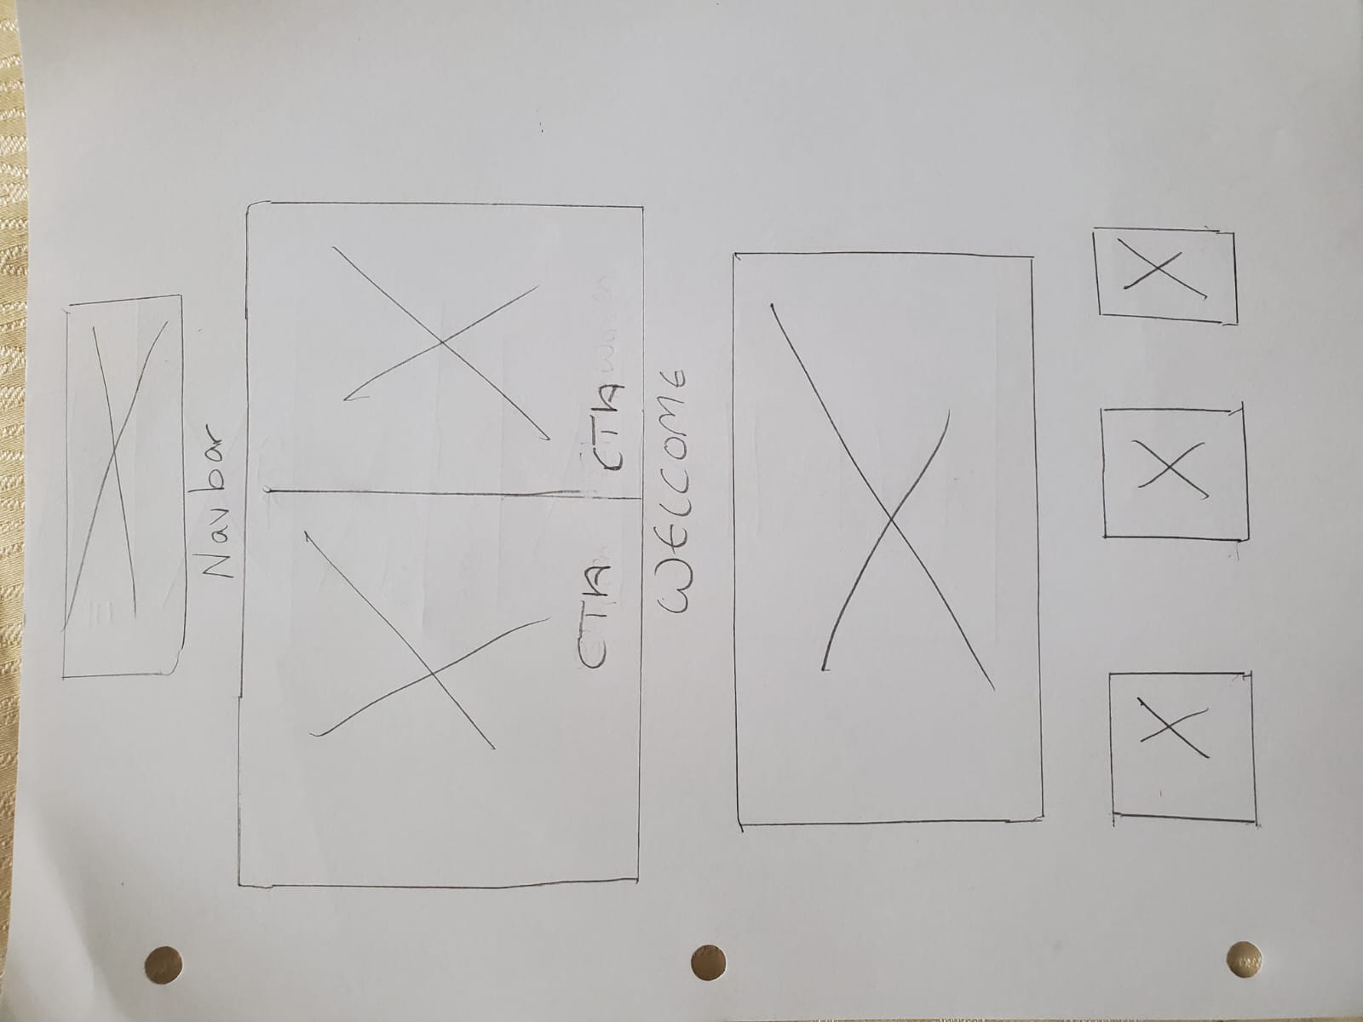

**MOBILE VIEW**

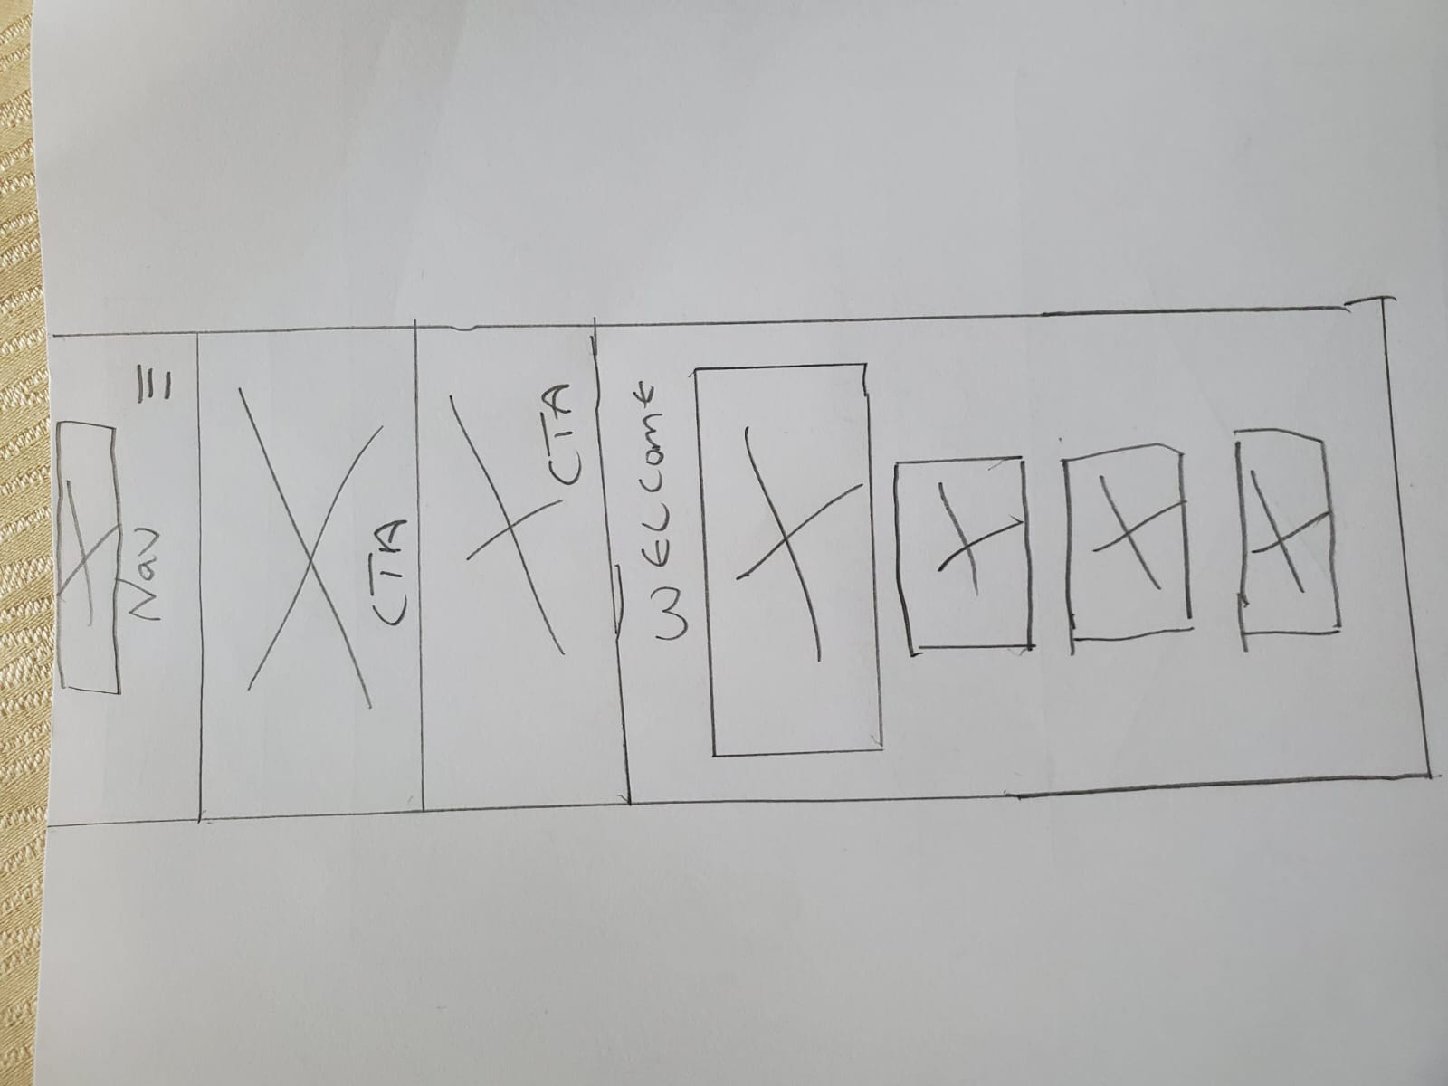

The Storyboard form is also there so you can see a summary of the data used to develop the e-commerce store **\*FOR ALL OF THE PAGES\***. I do hope that you are, please.

| Storyboard Form | | | |
| --- | --- | --- | --- |
| Website Project Name: *Cyron’s Clothing Store* | | | |
| Page Title: INFO 0211 WEBDESIGN | | | File name: 20201235cyronhercules |
| Layout Type: *1 column responsive* | | | |
| Purpose of page | | To make Cyron’s clothing store supplies more accessible | |
| Meta Data | | Title tags, Meta description, Viewport tag, Hreflang tags, link tags and script tag | |
| Links on the page | | Home, About, Contact, Faq, Safety Policies, login, Men and Women | |
| User Interaction | | Navigation Links, Animation Slide | |
| Graphical Elements/Images | | Icons, Images and buttons | |
| Style - Color specs and Font specs | | Fonts: Montserrat, Ubuntu, Poppins, Franklin Gothic Medium, Arial Narrow, Arial, sans-serif, Helvetica, Segoe UI, Tahoma, Geneva, Verdana, Lobster, Abel  Color spec: Light whitish-grey | |
| Structural/Semantic Details | | Html, head, body, div, section, main, header, span, ul, nav, form | |
|  | | | |